**If-Else in Python**

**Program 1**

**Objective:** To check for age above 18 using if-else statement

**CODE:** age = int(input("Enter age"))

if age >= 18:

print("Your age is 18+")

print("You are eligible to vote")

print("This statement is outside the body of if statement")

**OUTPUT:**

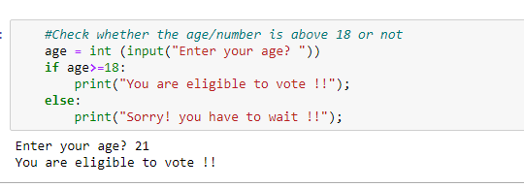

**Program 2**

**Objective:** To check for even or odd number using if-else statement

**CODE :**

num = int(input("Enter a number: "))

if (num % 2) == 0:

print("{0} is Even number".format(num))

else:

print("{0} is Odd number".format(num))

**OUTPUT:**

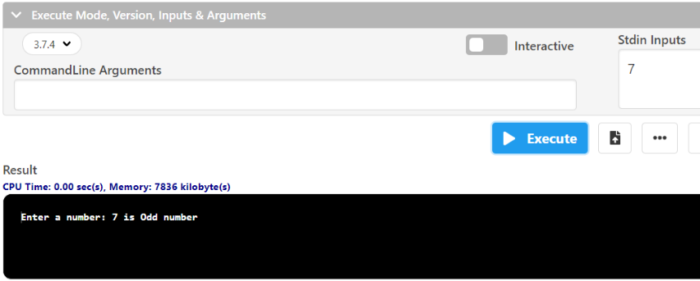

**Program 3**

**Objective:** To check for the number which equals to 10, 50, 100 using if-else statement

**CODE & OUTPUT:**

number = int(input("Enter the number?"))

if number==10:

print("number is equals to 10")

elif number==50:

print("number is equal to 50");

elif number==100:

print("number is equal to 100");

else:

print("number is not equal to 10, 50 or 100");

**Program 4**

**Objective:** To check length of lists given

**CODE & OUTPUT:**

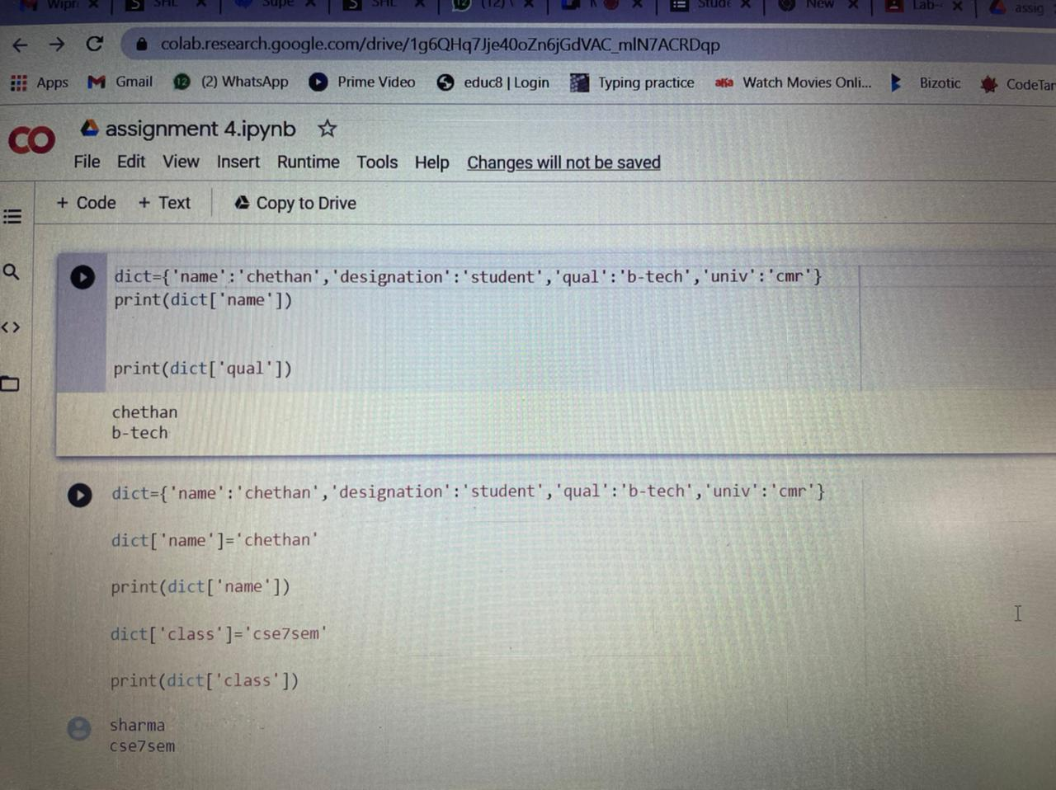

**Program 5**

**Objective:** To add the values to existing list

**CODE & OUTPUT:**

**Program 6**

**Objective:** To count for the occurrence of values in list

**CODE & OUTPUT:**

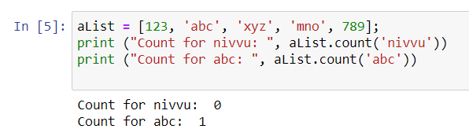

**Program 7**

**Objective:** To add the values to an existing list using another list

**CODE & OUTPUT:**

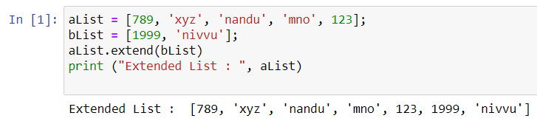

**Program 8**

**Objective:** To check for index values of the elements in the list

**CODE & OUTPUT:**

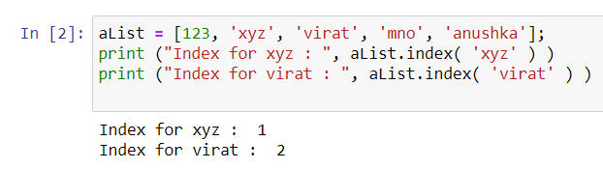

**Program 9**

**Objective:** To insert value/element at specific index value

**CODE & OUTPUT:**

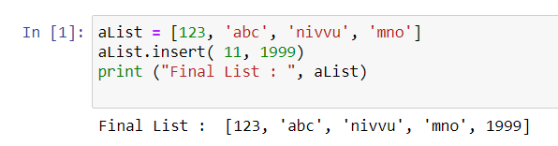

**Program 10**

**Objective:** Pop function in list

**CODE & OUTPUT:**

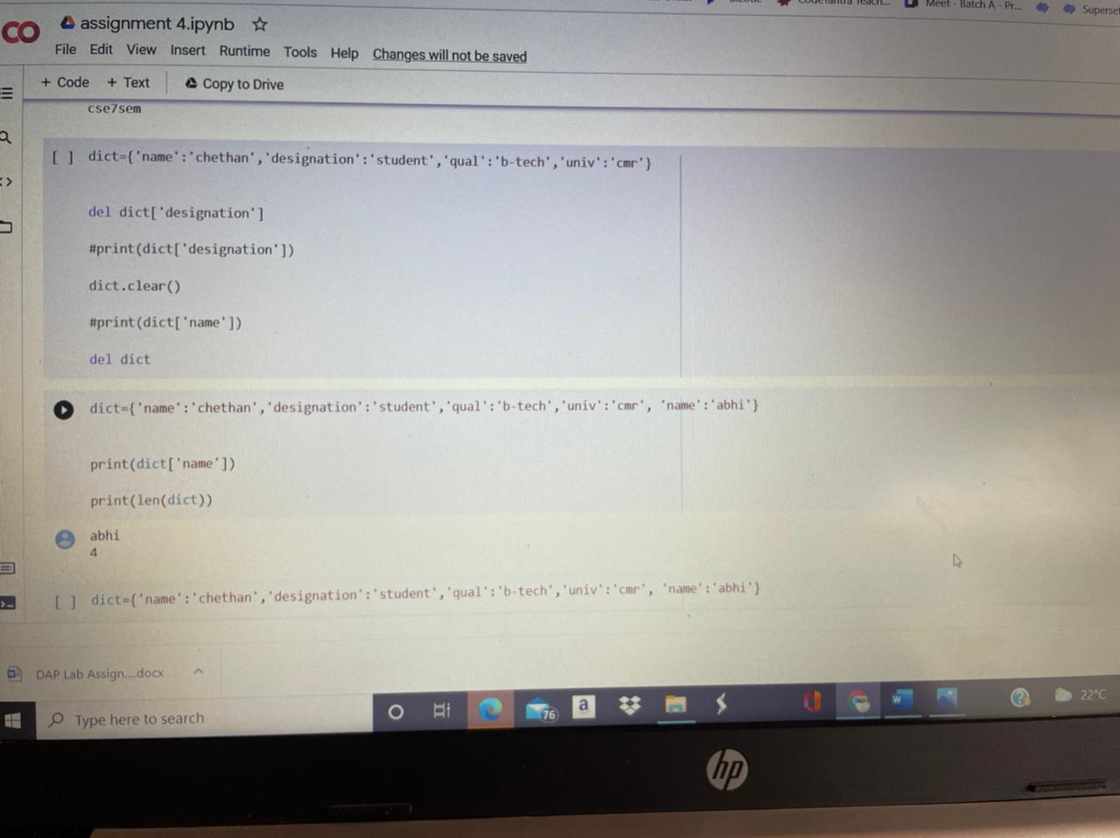

**Program 11**

**Objective:** Reversing of list in python

**CODE & OUTPUT:**

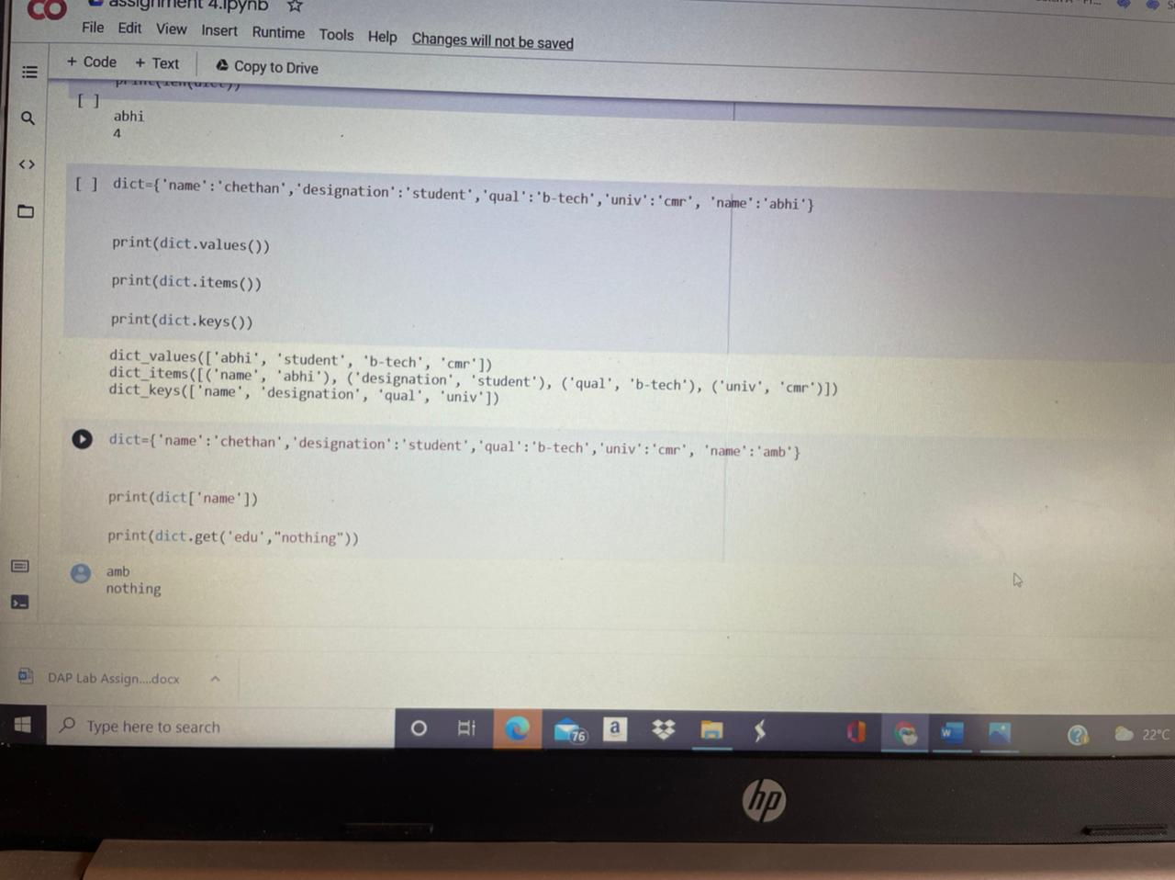

**Program 12**

**Objective:** To remove the value in the list

**CODE & OUTPUT:**

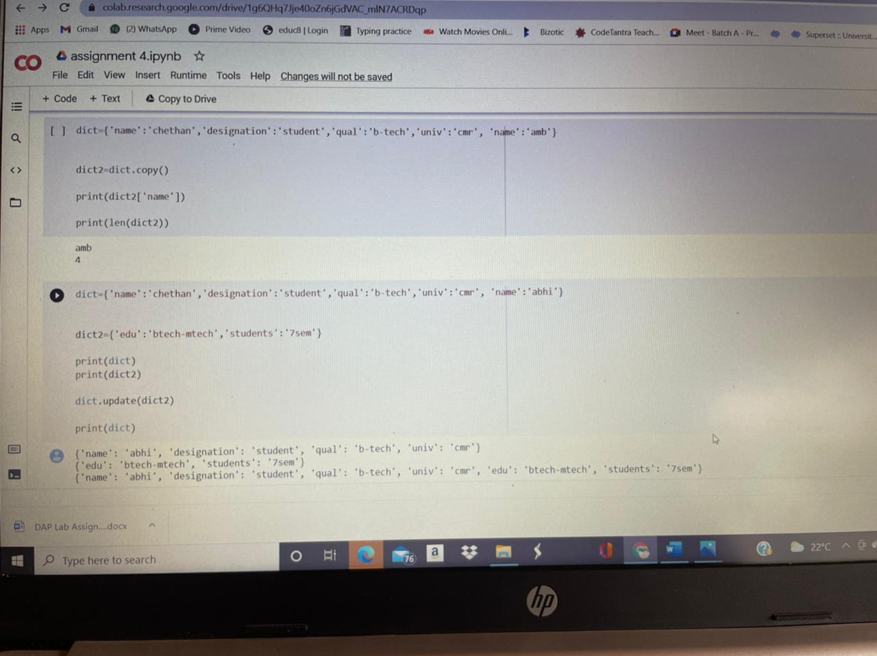

**Program 13**

**Objective:** To sort the list

**CODE & OUTPUT:**

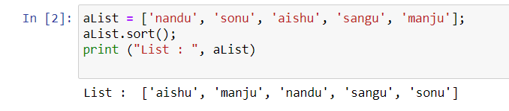

**Loops-Breaks—Continue Pass in Python**

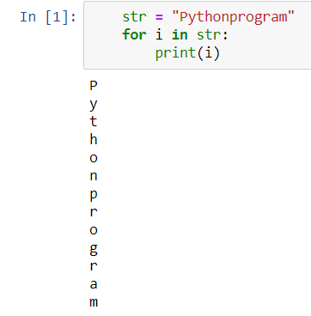

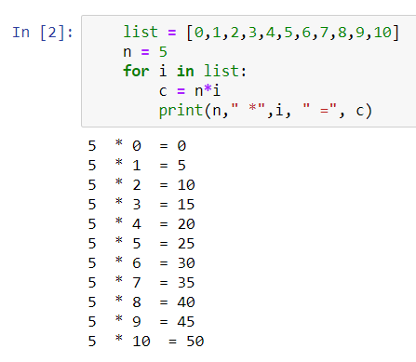

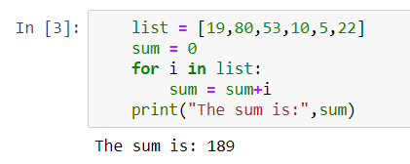

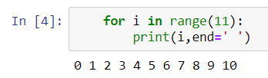

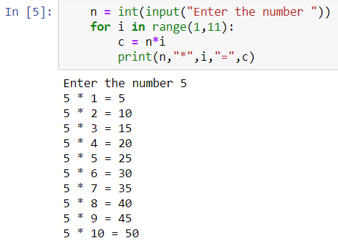

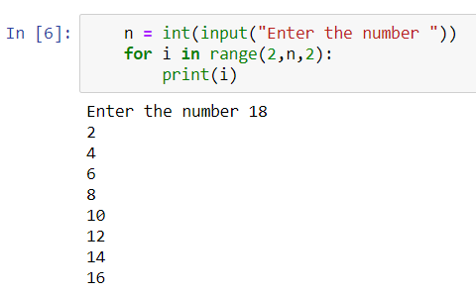

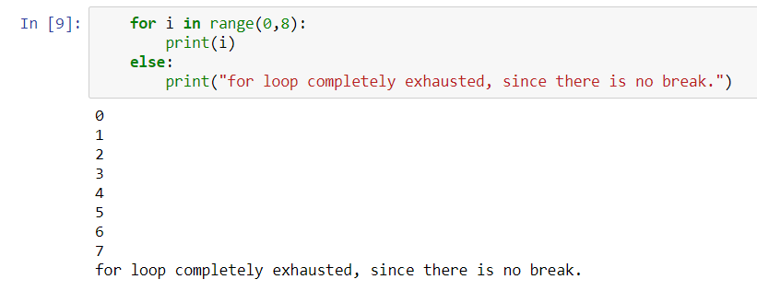

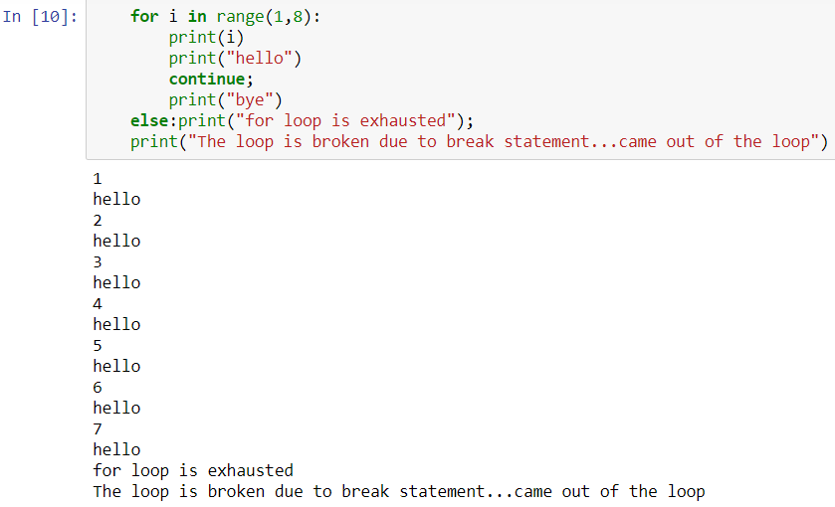

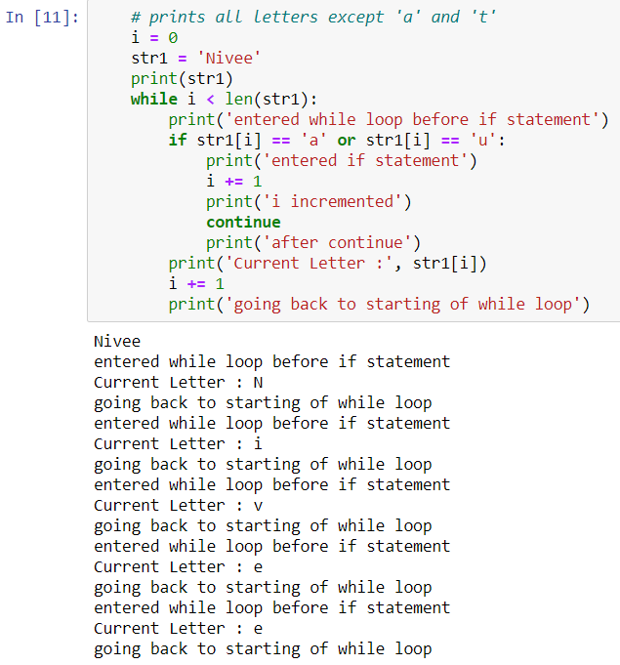

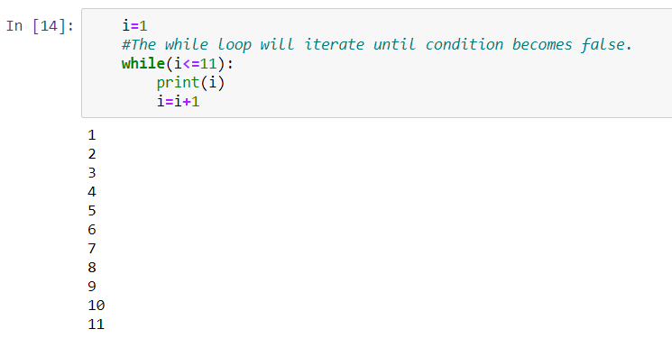

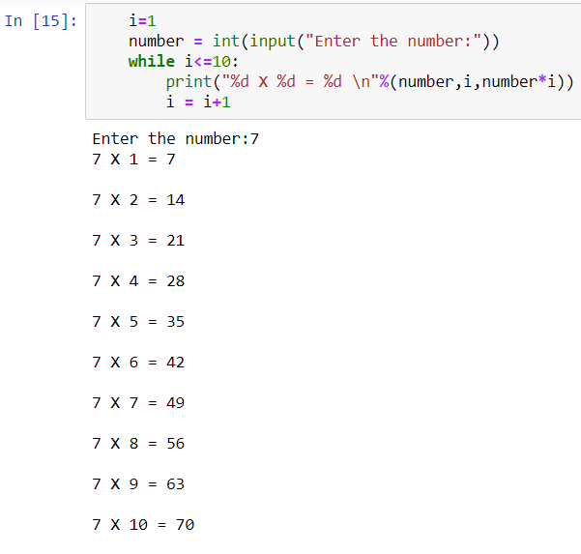

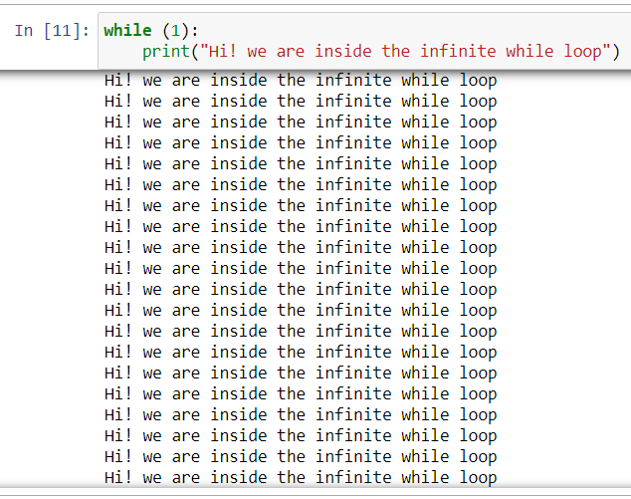

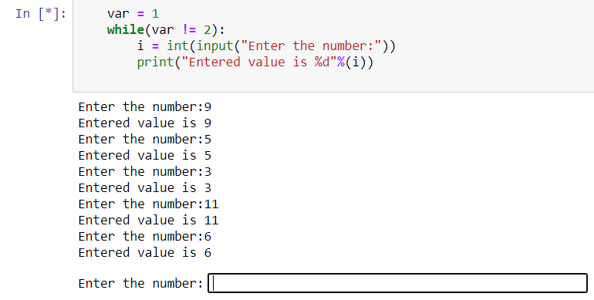

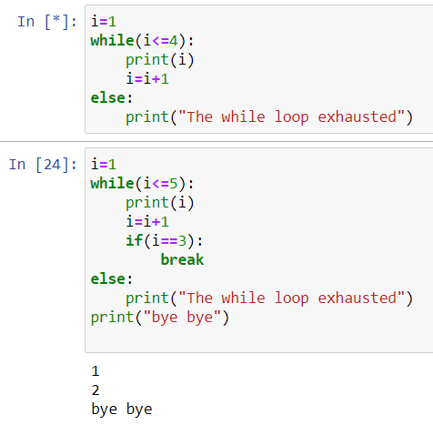

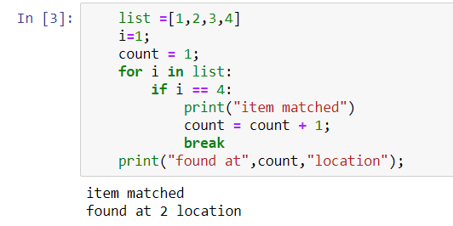

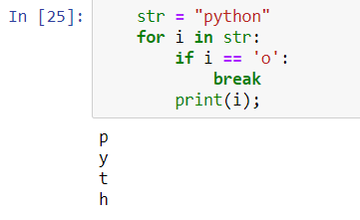

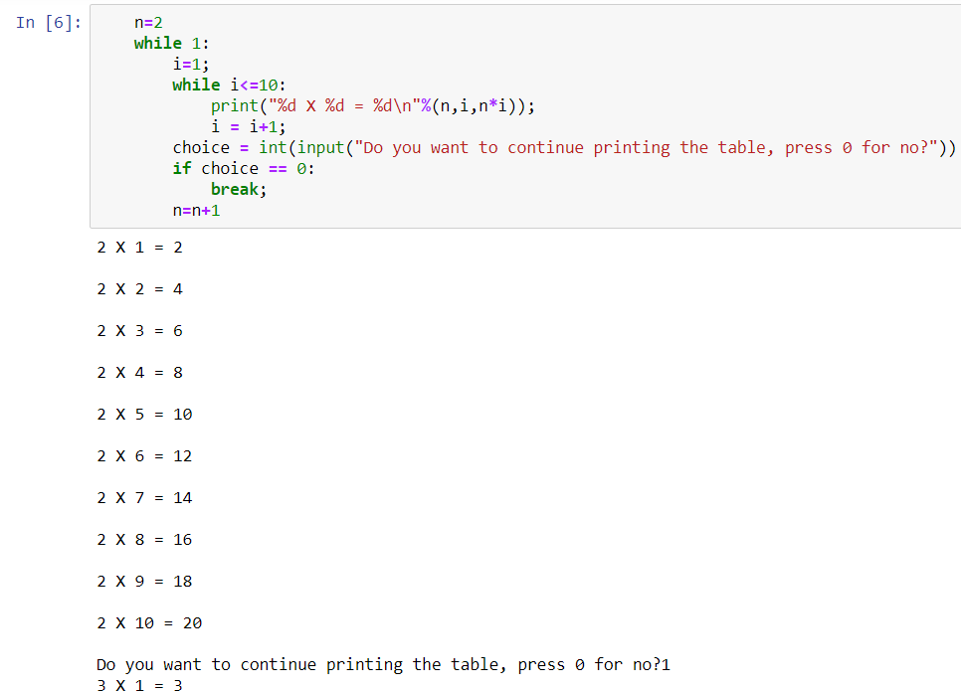

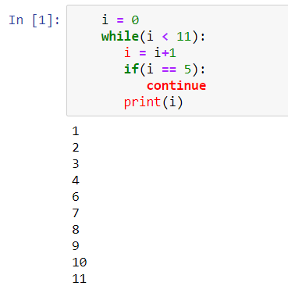

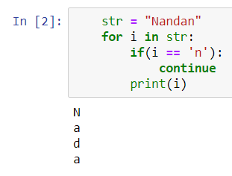

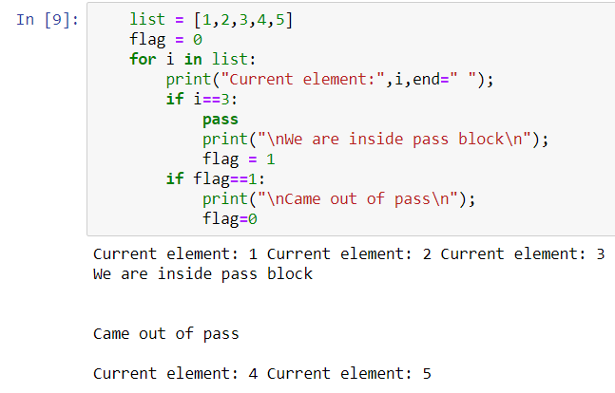

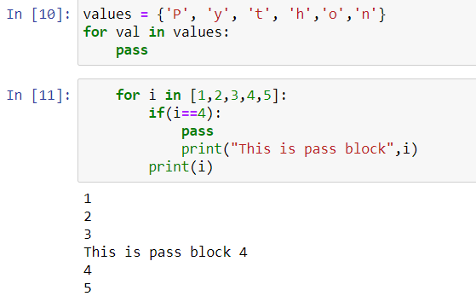

**Lists in Python**

**Strings in Python**

**Program 1**

**Objective:** Code to print/combine the given two strings into one

**Code & Output:**

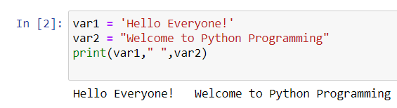

**Program 2**

**Objective:** code to print elements present at specific index value

**Code & Output:**

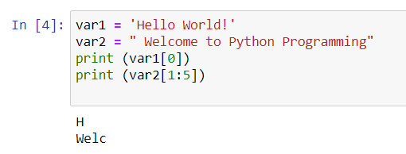

**Program 3**

**Objective:** To change the specific string value in python

**Code & Output:**

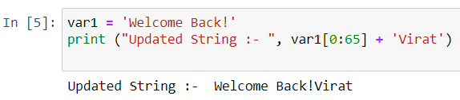

**Program 4**

**Objective:** To print the values present at given index location

**Code & Output:**

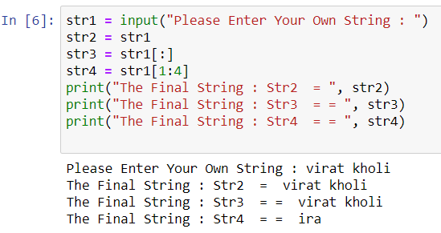

**Program 5**

**Objective:** Capitalize function in python which capitalizes only its first character.

**Code & Output:**

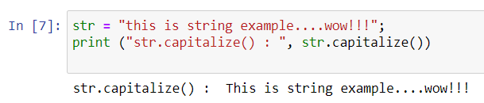

**Program 6**

**Objective:** To return centered in a string of length width. Padding is done using the specified fillchar. Default filler is a space.

**Code & Output:**

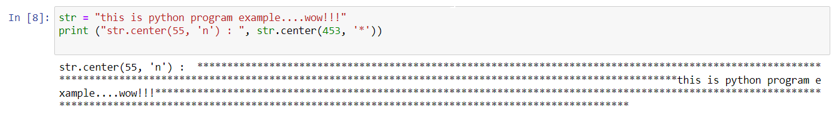

**Program 7**

**Objective:** To return the number of occurrences of substring sub in the range [start, end]

**Code & Output:**

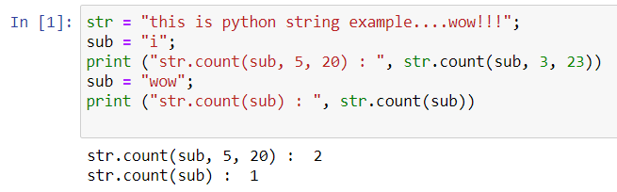

**Program 8**

**Objective:** To determine if string str occurs in string, or in a substring of string if starting index beg and ending index end are given.

**Code & Output:**

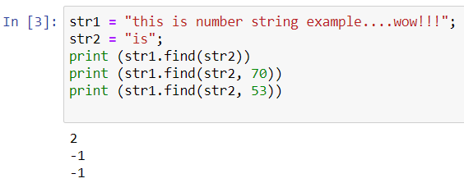

**Program 9**

**Objective:** To checks whether the string consists of alphanumeric characters.

**Code & Output:**

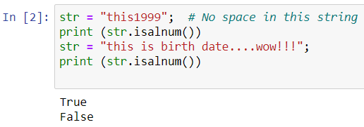

**Program 10**

**Objective:** To check whether string consist of alphabets and numbers without spaces using isalpha and isdigit.

**Code & Output:**

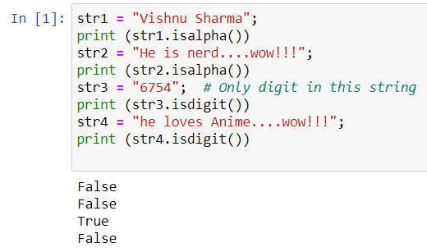

**Program 11**

**Objective:** To check whether the string first letter is a small letter

**Code & Output:**

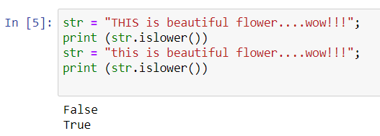

**Program 12**

**Objective:** To check whether the string is empty with only space

**Code & Output:**

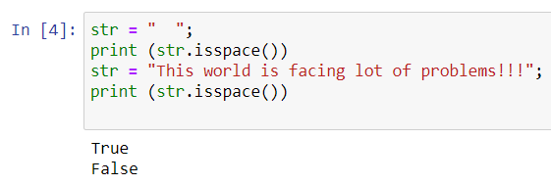

**Program 13**

**Objective:** To check whether strings every first character after space is capital using istitle and to check if all character in string is capitalized using isupper

**Code & Output:**

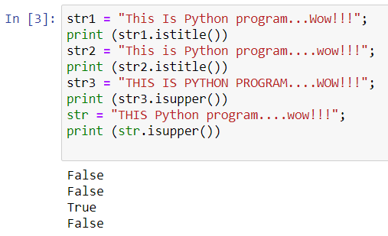

**Program 14**

**Objective:** To use join() function which returns a string in which the string elements of sequence have been joined by str separator.

**Code & Output:**

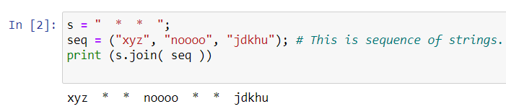

**Program 15**

**Objective:** To check for the length of string

**Code & Output:**

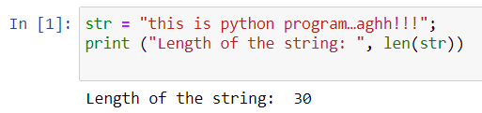

**Program 16**

**Objective:** To use istrip() function which returns a copy of the string in which all chars have been stripped from the beginning of the string (default whitespace characters)

**Code & Output:**

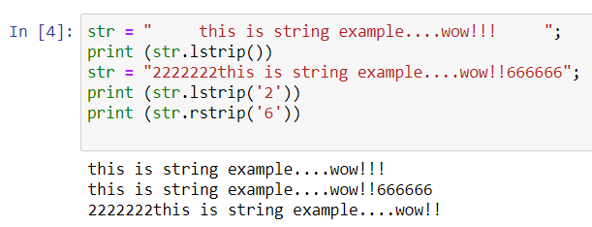

**Program 17**

**Objective:** To use lower () and capitalize function which convrts the string to lower and upper cases respectively

**Code & Output:**

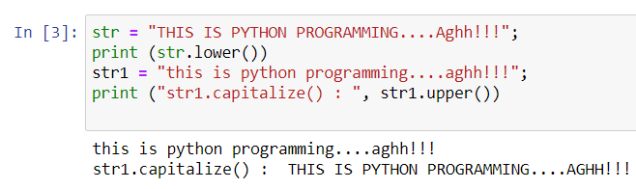

**Program 18**

**Objective:** To use max() function which returns largest character

**Code & Output:**

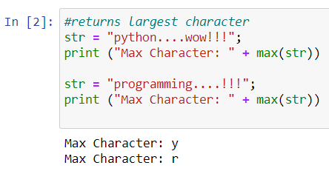

**Program 19**

**Objective:** To use min() function which returns smallest character

**Code & Output:**

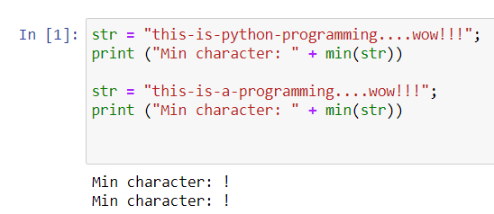

**Program 20**

**Objective:** To replace a certain character in string with another character

**Code & Output:**

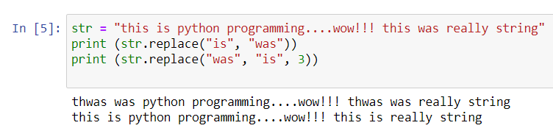

**Program 21**

**Objective:** To swap the two strings using swapcase() function

**Code & Output:**

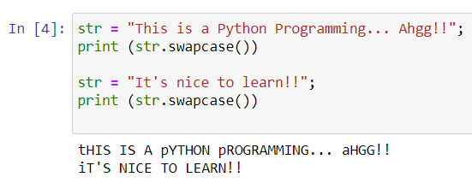

**Dictionaries in Python**

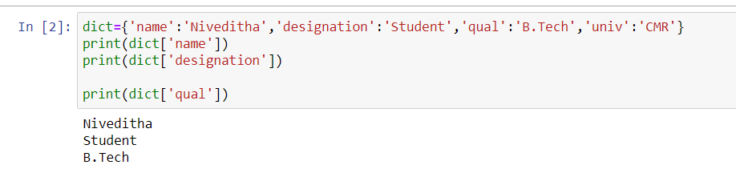

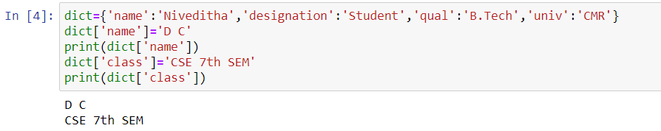

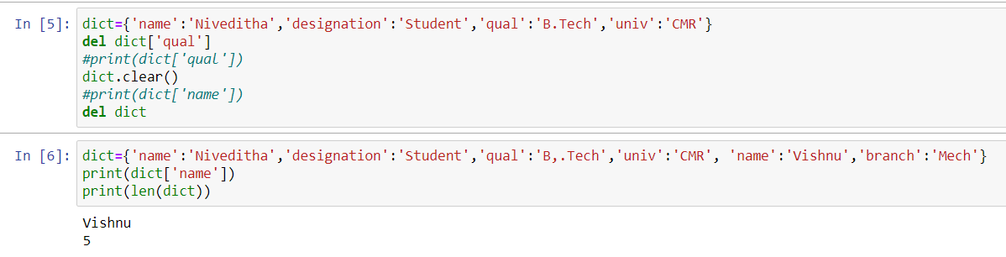

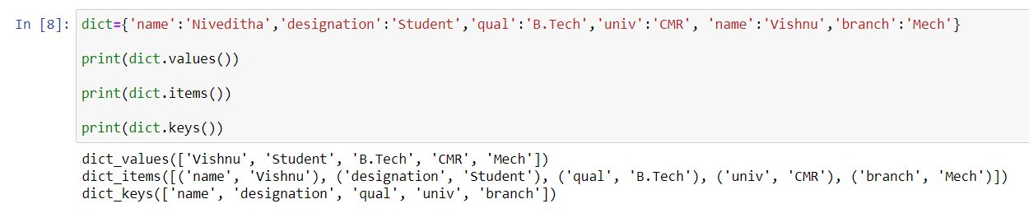

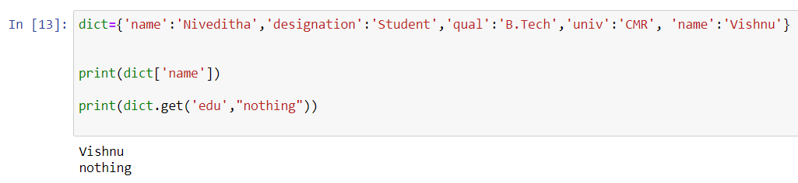

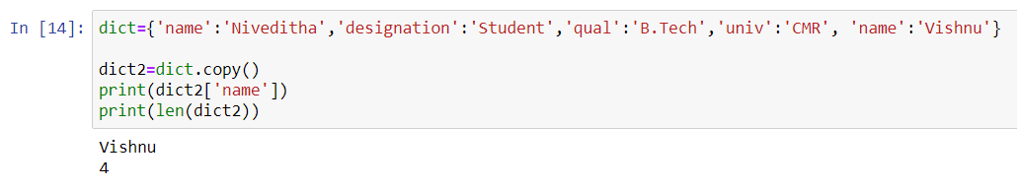

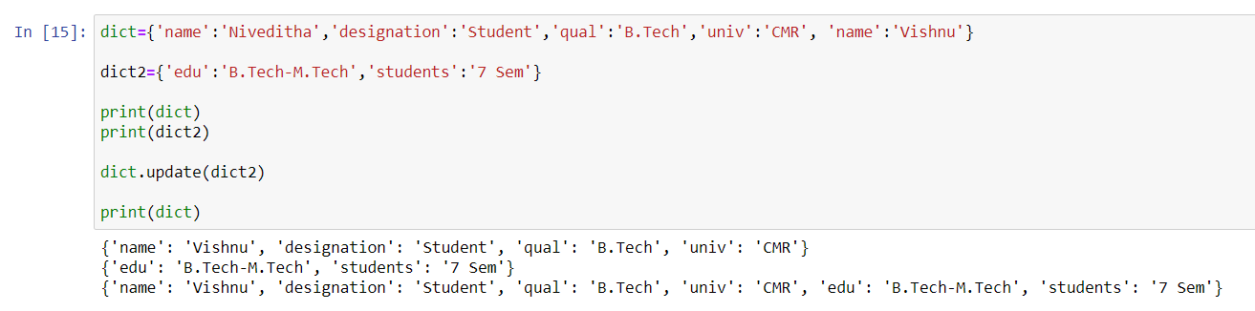

**Tuples in Python**

**TUPLES in Python**

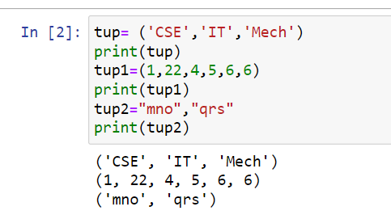

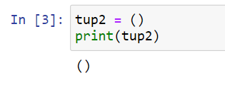

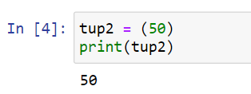

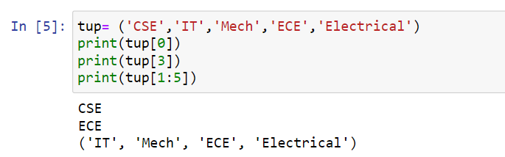

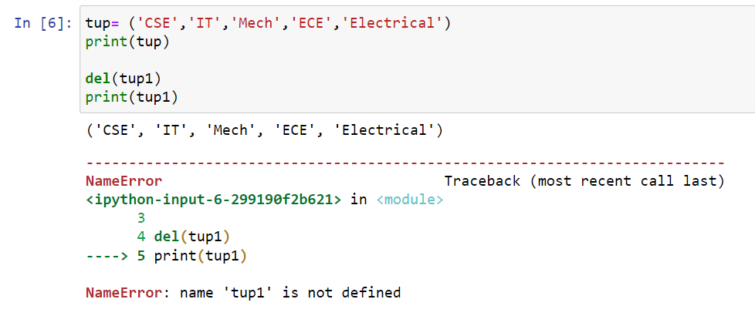

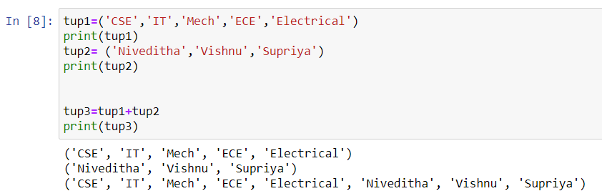

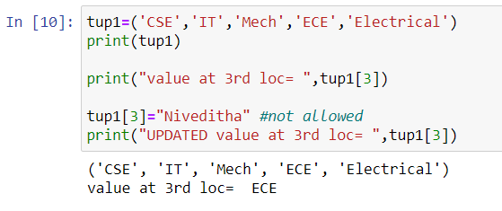

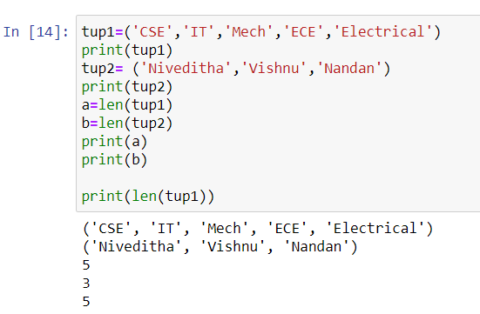

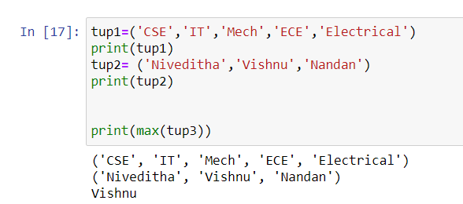

**Files in Python**

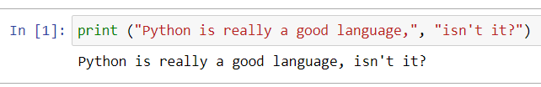

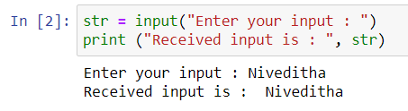

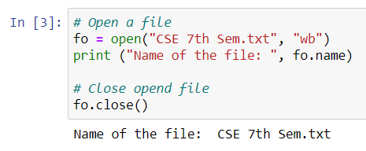

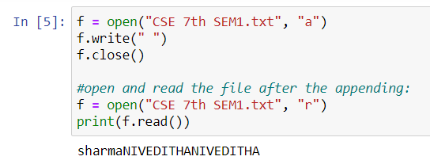

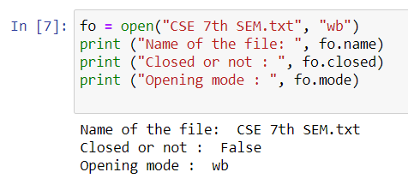

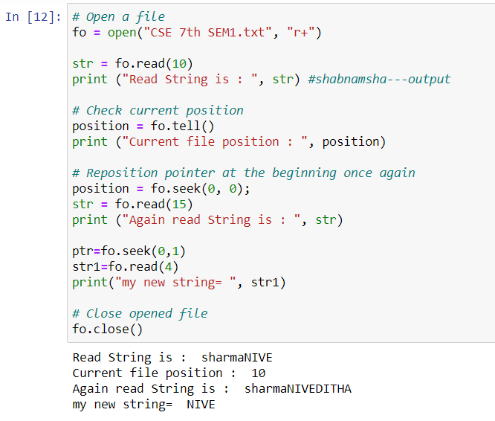

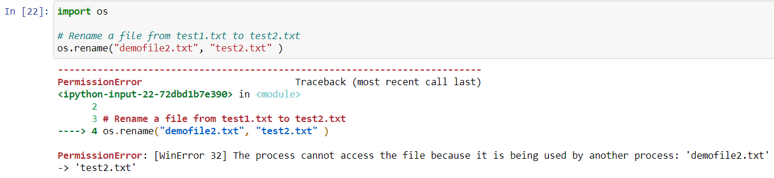

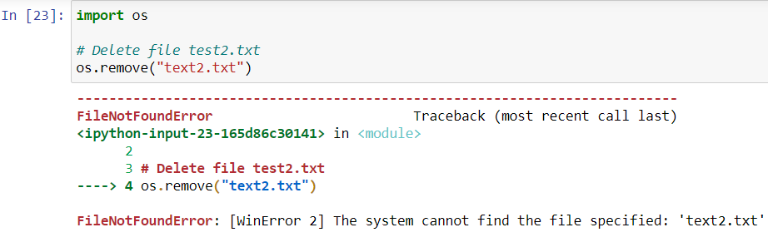

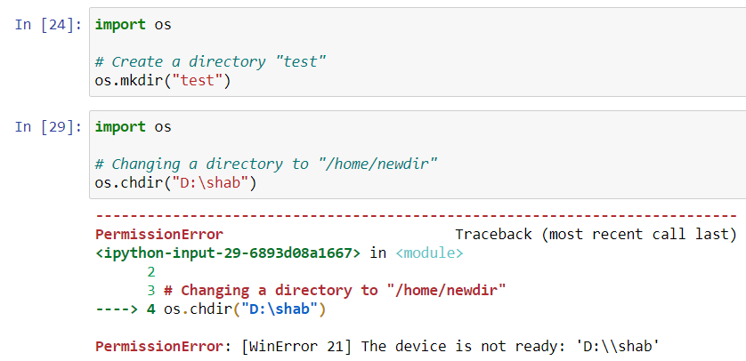

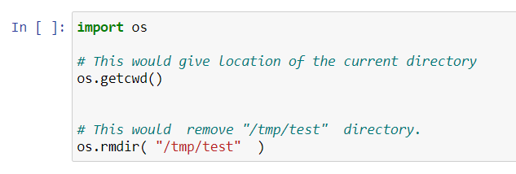

**NumPy in Python**

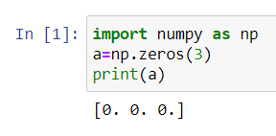

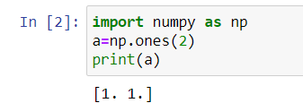

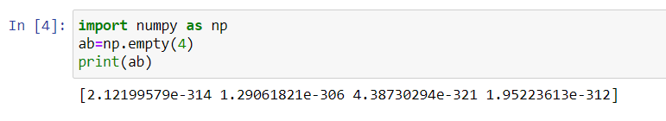

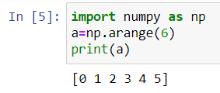

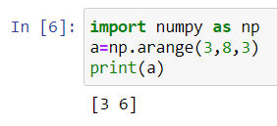

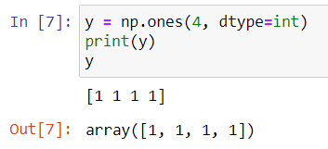

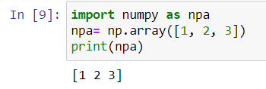

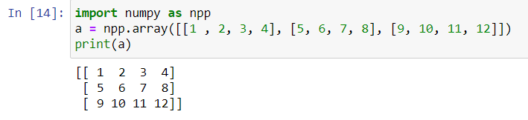

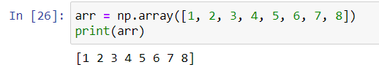

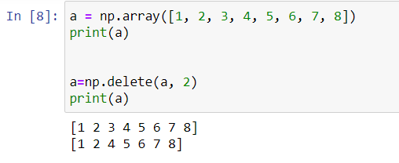

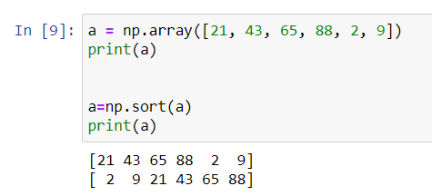

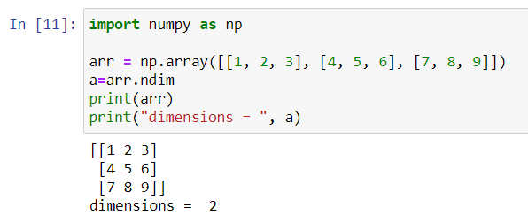

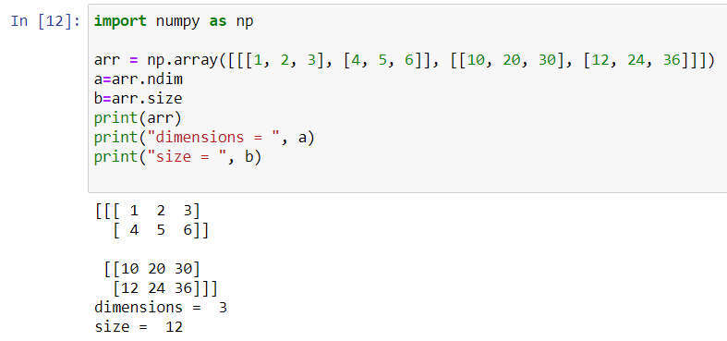

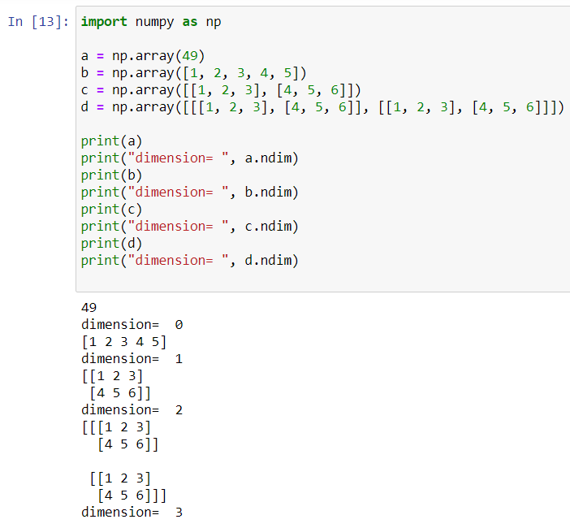

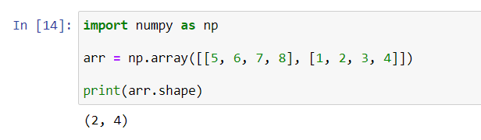

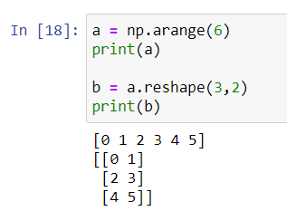

**NumPy Arithmetic OP in Python**

